IGU International Geographical Union |  |  |  | Union Géographique International UGI
IGU E-NEWSLETTER

Quarterly
URL: http://www.homeofgeography.org/
e-mail: g.bellezza@homeofgeography.org
or: giuliano.bellezza@gmail.org
New Series 22 |  | April |  |  | 2017
Editor: Giuliano Bellezza

This Newsletter is circulated to nearly 2000 individuals and bodies. Announcements, information, calls for participation in scientific events, programmes and projects are welcome. Please send them to giuliano.bellezza@gmail.com or g.bellezza@homeofgeography.org

CONTENTS OF THIS ISSUE

1) Remarks from IGU President Yukio Himiyama

2) Integration of Professor J. Stoltman to the Minutes of Paris EC Meeting

3) Procès verbale de la Réunion du IGU EC à Paris, 14-17 Novembre 2017

4) Thank messages from the 2016 Young Geographers Awardees in Beijing

5) Reports of recent events
5.1) IGU Conference on ‘Urbanization, Health & Well Being and Sustainable Development Goals’
5.1a) IGU-YECG Late Dr. Manju Singh Memorial Young Scientist Poster Award:
A Report
5.1b) Visit to the Osmania Human Resources Development Center

6) Presentation of a new IGU Commission

7) ICSU Newsletter, March 2017

8) Future Earth News, March 2017

9) Forthcoming events
9.1) Balsillie, Ontario, 23-27 May
9.2) HEA’d17 3rd Conference on Higher Edu, Valencia (Spain), 21-23 June.
9.3) ACLA Conference, Urban Cultural Landscape and Urban Regeneration, Vladivostok, 22-24 July.
9.4) IGU Commission History of Geography, International Symposia, Rio de Janeiro, 23-29 July 2017
9.5) International Conference on Natural Computation, Fuzzy Systems and Knowledge Discovery, Guylin (China), 28-31 July

1) Remarks from President yukio himiyama

You may have been surprised, if not shocked, by the ban on entry for people of certain national origin to the US, which was proclaimed on 27 January 2017. With its annual conference in Boston only a couple of months ahead, AAG (American Association of Geographers) reacted quickly by issuing the “AAG Statement on President Trump’s Executive Order” on 30 January 2017 (http://news.aag.org/2017/01/aag-statement-on-president-trumps-executive-order/, already appeared in the January 2017 IGU Newsletter)). It was followed by the statement of the ICSU (International Council for Science) on 31 January, which called on the government of the United States to rescind the Executive Order, saying that the Order was inappropriately broad in its scope and unfairly targeted individuals based on their origin, placing it into violation of the Principle of Universality of Science, enshrined in the Council’s Statutes (see http://www.icsu.org/news-centre/press-releases/press-releases-2017/ ).

Although to some it may simply be an isolated domestic issue in a super-power country, on the other it is representative of the increasingly uneasy situation facing the global academic community. It is worth recalling that the IGU Statutes (article C) state that the IGU adheres to both ICSU and the International Social Science Council (ISSC), and recognizes them as providing coordinating and representative bodies for the international organization of science. The IGU Executive Committee placed the ICSU statement on its website and, moreover, worked directly with ICSU in its dissemination.

ICSU and ISSC, which together represent a large part of academic community of the world, are currently in the process of formalizing a merger. The IGU has been a leading supporter of the merger in the hope that the world’s mutual understanding, togetherness, prosperity, sustainable development, and peace are enhanced by the unified power of the global academic community. These issues are of great concern to geographers and, with more than forty Commissions and Task Forces, over a hundred National Committees, and many active individuals, IGU as the representative body of the world geographic community is expected to make substantial contributions to promoting such issues.

In the middle of March I visited Hyderabad, India, and attended the International Conference on “Urbanization, Health and Wellbeing, and Sustainable Development Goals,” which was acknowledged by the IGU as one of its newly defined IGU Thematic Conferences. It was coordinated by the Indian National Committee for IGU, hosted by Osmania University, and sponsored by some IGU Commissions. In the January 2017 issue of IGU E-Newsletter, I noted that Future Earth functioned as the major academic platform for implementation of the United Nation’s Sustainable Development Goals (SDGs), and that the National Committees for IGU had a grand opportunity to contribute to their government as specialists of some of the SDGs. The Hyderabad Conference represented a very good model of how such initiatives can be fostered by a National Committee. As I am writing this note, another IGU Thematic Conference, on “Geographies for Peace”, is in progress in La Paz, Bolivia. There are more Thematic and other Conferences of IGU to come in the coming months, so please visit the IGU website regularly so as not to miss the information of your interest.

In the middle of March I visited Hyderabad, India, and attended the International Conference on “Urbanization, Health and Wellbeing, and Sustainable Development Goals,” which was acknowledged by the IGU as one of its newly defined IGU Thematic Conferences. It was coordinated by the Indian National Committee for IGU, hosted by Osmania University, and sponsored by some IGU Commissions. In the January 2017 issue of IGU E-Newsletter, I noted that Future Earth functioned as the major academic platform for implementation of the United Nation’s Sustainable Development Goals (SDGs), and that the National Committees for IGU had a grand opportunity to contribute to their government as specialists of some of the SDGs. The Hyderabad Conference represented a very good model of how such initiatives can be fostered by a National Committee. As I am writing this note, another IGU Thematic Conference, on “Geographies for Peace”, is in progress in La Paz, Bolivia. There are more Thematic and other Conferences of IGU to come in the coming months, so please visit the IGU website regularly so as not to miss the information of your interest.

Yukio Himiyama
President of IGU

2) Comptes rendu de la Réunion du Comité Exécutif de l’IGU
à Paris, MAISON DE LA RECHERCHE, 14-17 Novembre 2017

Bienvenue, logistique de la réunion et présentations
La réunion a été présidée par le président Himiyama, qui a accueilli le Secrétaire général Mike Meadows et les vice-présidents Joos Droogleever-Fortuijn, Barbaros Gönençgil, Iain Hay, Vladimir Kolosov, Nathalie Lemarchand, Rémy Tremblay, Zhou Chenghu (avec Ma Xiaoyi assistante).

Adoption de l'ordre du jour

L'ordre du jour, préparé et distribué avant la réunion, a été adopté. Cette réunion étant la première pour plusieurs nouveaux membres, de brèves présentations furent faites.

Procès-verbal

Le compte-rendu de la réunion de Bejing en Août 2016, déjà approuvé par courriel, a été déposé à titre de référence et avec une correction éditoriale mineure fut confirmé.

Organisation et opérations

Rapports des membres du comité exécutif. Du fait du laps de temps très court entre la précédente réunion du comité exécutif et celle-ci, les membres n'ont pas été priés de présenter des rapports écrits sur leurs activités liées à l'UGI.

Calendrier 2017 du Comité Exécutif. L’agenda du comité exécutif pour les deux prochaines années a été discuté. Il a été décidé que la première réunion de 2017 se tiendrait à Québec, Canada, en mai : arrivée le 7, réunions les 8 et 9, possible excursion le 10 et départ le 11 mai. La seconde réunion de 2017 aura lieu en septembre à Amsterdam : arrivée le 6, réunions les 7 et 8, excursion possible le 9 et départ le 10 septembre. Himiyama a offert d'accueillir la première réunion de 2018 au Japon, de préférence à Tokyo, au début d'avril, dates envisagées : arrivée le 9, réunions les 10 et 11, départ le 12 ou le 13 dépendant d’une excursion. Il y aurait également une réunion immédiatement avant ou après la Conférence régionale de Québec en août 2018 (les dates sont du 6 au 10 août 2018). Les arrangements pour la réunion finale de 2018 ne pourront être pris qu’après l'élection de nouveaux membres du comité exécutif (mi-2018).

Stratégie de l’UGI 2016-22. La stratégie originelle, établie initialement par Kolosov au début de son mandat Présidentiel et suivie de plusieurs itérations, a été déposée. Himiyama a souligné que nous devrions poursuivre ces efforts et, en particulier, pour renforcer et souligner le rôle et les activités des Commissions et des Comités Nationaux, notamment en ce qui concerne Future Earth et IYGU. Les informations à propos de Future Earth et IYGU doivent être régulièrement suivies pour s’assurer que les Commissions concernées soient alertées et s'impliquent, quand cela semble approprié. De nouvelles initiatives et des projets spéciaux pourraient devoir être développés au cours des quatre prochaines années ; des opportunités créatives et innovantes peuvent exister en lien avec des organismes extérieurs, comme Future Earth et CIPSH (Conseil International de la Philosophie et des Sciences Humaines), autant qu’avec IYUG, porté par l’UGI. La mise en œuvre de la stratégie exige une meilleure division du travail que cela n'a été le cas jusqu'ici. Cela a été longuement discuté; le document de stratégie indique les principaux objectifs, les activités et les éléments clés qui ont été soulevés et, quand c'est nécessaire, les responsabilités qui ont été réparties entre les différents membres du C.E. Il a été convenu de reprendre ces questions importantes au début de la réunion de mai 2017 du C.E. au Québec.

Responsabilités des membres du C.E. Le nouveau Comité exécutif a examiné la liste des comités nationaux de l'UGI et s’est entendu pour affecter les responsabilités de liaison comme indiqué à l'annexe 1.

Rapport financier et projection de l'UGI. Étant donné le peu de temps écoulé depuis la dernière réunion du Comité exécutif, Meadows n'a pas déposé de rapport financier écrit, mais a confirmé que la situation financière demeure bonne. Conformément aux recommandations du Sous-Comité des finances à l'Assemblée générale à Beijing, Meadows a accepté d'employer un assistant pour aider à finaliser les comptes de 2017 et un professionnel qualifié pour les valider.

Mise à jour de l'adhésion nationale à l'UGI. Meadows a présenté une mise à jour sur la situation de l'adhésion nationale. Hay a rapporté qu'il avait abordé plusieurs nations en Océanie en vue d'encourager leur adhésion et que cela a été suivi d’effet par certains d'entre eux. Le paiement des cotisations de la nouvelle adhésion nationale approuvée à l'Assemblée Générale à Bejing a été décevant et nécessite d’assurer un suivi (Meadows). La demande de Samoa a été déposée et il a été convenu que cela satisfait aux exigences habituelles et un bulletin de vote par courriel de l'Assemblée générale sera lancé pour obtenir l'autorisation nécessaire (Meadows). Une demande de Fidji est également prévue prochainement. Meadows a accepté de rédiger une lettre à distribuer aux présidents des comités nationaux en passant par la liaison des membres du C.E.

Mise à jour des commissions et des groupes de travail de l’UGI. Dell'Agnese a signalé qu'elle a progressé dans plusieurs des commissions suspendues. Le nouveau comité exécutif a examiné la liste des commissions et groupes de travail de l'UGI et a attribué les responsabilités de liaison comme indiqué à l'annexe 2. Il a été suggéré que les listes des membres du comité directeur pour chaque commission et groupe de travail soient mises à disposition sur la page des commissions du site Web de l'UGI (Meadows). La proposition d’une nouvelle commission sur la géographie et l’ingénierie agricole a été déposée. Depuis la discussion initiale sur cette commission lors de la dernière réunion du C.E., la proposition a été révisée. Il y a eu des discussions approfondies sur la relation entre cette commission et celle, entre autres, sur la durabilité des systèmes ruraux. Le principe de la commission a été accepté mais les auteurs de la proposition doivent veiller à être en contact direct avec d'autres commissions compétentes sur ces sujets (en particulier celle sur la durabilité rurale) pour éviter les situations de chevauchement et doivent s'assurer que la structure d'adhésion au comité de pilotage répond aux exigences légales de l'UGI. Cela devra être rapporté au plus tard au moment de la prochaine réunion de la CE (Zhou suivra). Les autres commissions compétentes sur le sujet doivent être informées du principe que cette nouvelle commission a été approuvée pour être établie (Meadows). Werlen avait déposé une nouvelle version de la commission sur la compréhension globale pour qu'il en soit pris note. Le comité de pilotage doit toujours être établi. Étant donné que Ron Abler et Dieter Soyez ont quitté le sous-comité du Prix d'excellence des commissions de l'UGI, Kolosov et Gönençgil ont accepté de les remplacer.

IYGU. Werlen avait transmis la dernière mise à jour sur l'IYGU. C'est un document impressionnant en termes de portée de ses activités et le C.E. a félicité le Directeur à ce sujet. Il y a une préoccupation sur la pérennité de l'ensemble de l'initiative dû au fait qu'elle est si dépendante des efforts extraordinaires d'une seule personne. Cela pourrait être un problème, surtout s'il doit y avoir une «Décennie de la compréhension globale», qui est l'un des scénarios suggérés. La commission sur la compréhension globale, nouvellement créée, doit être considérée comme une ressource clé en ce qui concerne la poursuite des activités de l'IYGU et Werlen doit consulter son comité de pilotage sur la façon dont le problème de la pérennité peut être réglé. On a demandé à Himiyama de communiquer ces préoccupations à Werlen et de souligner que si la «Décennie» est maintenue, l'approbation de l'UGI sera conditionnée à une solution satisfaisante au défi de la pérennité. Les commissions actuelles doivent également être encouragées à interagir avec l'IYGU. La demande de financement au CIUS à la suite de l'appel de 2016 a été soumise à temps et cela est très fléché sur l'IYGU. La proposition est faite avec un co-demandeur (l’Union internationale des sciences anthropologiques et ethnologiques), et soutenu par deux autres unions scientifiques (l’Union Internationale des Sciences Psychologiques et l’Union Internationale des Sciences du Sol).

Initiative de l’UGI pour l’Afrique et l’Amérique latine. Des sessions consacrées aux géographes africains et latino-américains avaient été convoquées au congrès de Bejing, bien qu’il y ait relativement peu de participants. Quelques idées utiles ont néanmoins émergé. Il a été suggéré que la communauté des géographes africains soit déjà active dans les initiatives de l'UGI pour former un groupe central pour favoriser un réseau plus large. Kenneth Matengu a accepté de poursuivre l'idée d'une conférence thématique en Namibie et l’indication d'une note conceptuelle en ce qui concerne un possible groupe de travail ou une éventuelle Commission pour l'Afrique a été prise en note et Meadows a accepté de suivre ces contacts. Lemarchand a un réseau au sein de l'Afrique francophone qui peut également être une ressource utile. La question a été soulevée quant à savoir si les organisateurs locaux de la Conférence régionale du Québec pourraient envisager la possibilité de générer des fonds pour soutenir la présence de géographes africains francophones et envisager une session ou des sessions spéciales sur l'Afrique (Tremblay). L'initiative latino-américaine a déjà une impulsion considérable de fait de la prochaine Conférence thématique de La Paz et des membres nationaux nouvellement élus de la région.

Évaluation internationale en géographie. Joseph Stoltman s'est adressé au C.E. pour l'approbation de l'idée d'une évaluation internationale apparaissant comme prochaine étape logique à la signature de la Charte internationale de l'éducation géographique. Plusieurs préoccupations ont été soulevées, notamment le fait qu’une approbation par rapport à cette proposition a déjà été exprimée dans une recherche menée par des géographes universitaires australiens. Les réponses proviennent de 36 pays. Le C.E. soutient une évaluation internationale significative et appropriée dans la discipline, mais estime qu'une approbation complète à ce stade est prématurée. La Commission de l'IGU sur l'éducation géographique doit être encouragée à continuer de développer l'idée et à l'approuver comme bon lui semble.

Site de l'UGI. Le site Web de l'UGI continue d'être mis à jour comme habituellement.

Projet Revues de l'UGI. La base de données a été mise à jour et les nouvelles informations sont en cours de chargement.

Bulletin de l'UGI. Les volumes 59-60 seront compilés au début de 2017. Meadows a accepté de les publier sur le site.

Bulletin électronique de l'UGI. Le travail de l'ancien vice-président Bellezza à ce sujet a de nouveau été salué et il est prévu qu'il continuera à produire le bulletin électronique trimestriel comme habituellement.

OurSus (Droogleever-Fortuijn). Les activités en association avec le Congrès de Beijing semblent suggérer un tournant pour OurSus et il existe maintenant plusieurs Commissions de l'UGI qui souhaitent participer au projet. Le financement a été obtenu auprès de la Société de Géographie de Chine et d'une des Beijing Normal Universities (BNU). Les perspectives de collaboration avec l'IYGU sont également discutées avec Werlen. La prépondérance des cas d’études de villes chinoises reste, mais Ton Dietz, qui a déjà identifié la participation possible de plusieurs nouvelles villes, pourra être encore plus actif avec OurSus avec son départ à la retraite académique en 2017. Droogleever-Fortuijn reste la personne-ressource du C.E. et communiquera à Li Qi et ses collègues l'impression positive que ces perspectives créent au sein de l'UGI. La possibilité d'un groupe de travail consacré à ce projet doit être explorée plus avant.

Conférences thématiques de l'UGI. La conférence thématique de Bakou, Azerbaïdjan, prévue à l'origine du 21 au 24 août 2017, n'aura pas lieu; Mamedov a indiqué que le gouvernement azerbaïdjanais n'est plus en mesure de fournir un soutien financier. Kolosov a proposé une alternative; 2017 ayant été proclamée «année de l'environnement» en Russie, il est soumis qu'une conférence thématique sur le thème «Les défis environnementaux au XXIe siècle» se tienne à Moscou en novembre 2017. Une première circulaire est en cours d’élaboration.
Le site web de la conférence thématique de La Paz, en Bolivie, est maintenant ouvert et est également présenté sur le site de l'UGI. Dell'Agnese fait un travail intense pour promouvoir cette conférence et solliciter des présentations sur les différents aspects du thème; elle organise également une excursion sur le terrain dans le cadre de la rencontre. Dell'Agnese et Kolosov participeront à la conférence et devront prendre toute une série de documents publicitaires de l’UGI pour l'affichage et la distribution. Meadows a accepté de mettre à jour le dépliant de l'UGI avec les nouveaux membres du C.E. et la liste révisée des commissions et des groupes de travail et diffusera les fichiers pdf une fois qu'ils auront été finalisés. Les membres du C.E. pourront ensuite imprimer des dépliants au besoin.
L'organisation de la conférence thématique "Urbanisation: santé et bien-être" de l'UGI à Hyderabad, en Inde, du 17 au 19 mars 2017 est en cours. Himiyama participera à cette conférence. Le matériel publicitaire de l'UGI est également requis pour cela.
Le président des comités des propositions infructueuses du Congrès de 2024 devrait être invité à envisager d'organiser une conférence thématique (Kolosov, Meadows, Hay).

Proposition de presse MIT. Meadows a reçu une proposition d'un éditeur commercial (MIT Press) pour promouvoir ses livres en lien avec la géographie en offrant un tarif réduit pour les «membres». L'UGI n'ayant plus d'adhésion individuelle, cette option est peu pratique, mais Hay a souligné que cette proposition soulève la possibilité plus large de développer un flux de revenus depuis des éditeurs de livres de géographie. Himiyama a indiqué qu'une augmentation substantielle du flux de revenus pourrait menacer le soutien financier des comités nationaux. Une solution possible à cela serait de suggérer que les éditeurs rémunèrent l'UGI pour un lien promotionnel ou un «pop-up» sur le site Web de l'UGI et que ces fonds soient utilisés pour promouvoir les objectifs de l'UGI, y compris, par exemple, faciliter l'adhésion des pays à plus faible revenu. Hay a convenu de faire avancer cette question en consultation avec Lemarchand et Tremblay, initialement avec le MIT, mais en vue d'étendre l'arrangement à d'autres éditeurs possibles en temps voulu.

Publications de l'UGI. Springer publie plusieurs séries avec une forte composante géographique, y compris la collection nouvellement proposée sur les Sustainable Development Goals (éditeurs : Singh, Mal et Meadows), la série en place de World Regional Geography (éditeur : Mulder) et celle sur les progrès en Advances in Geographical and Environmental Sciences (éditeur : Singh). Le logo de l'UGI peut être utilisé sur la couverture de ces volumes, à condition qu'il y ait une brève description de l'implication de l'UGI sur la couverture arrière ou tout autre endroit approprié.

Coopération et sensibilisation

Festival International de Géographie. Il semble toujours y avoir des défis concernant la coopération entre le FIG et l'UGI. Lemarchand a rendu compte de discussions informelles avec les organisateurs locaux et d'autres, y compris Jean-Robert Pitte, et il est clair qu'une telle coopération doit être mutuellement bénéfique. Le pays invité en 2017 est l'Afrique du Sud. Lemarchand a accepté de poursuivre ces discussions avec les personnes concernées.

Représentants de l'UGI dans les organismes internationaux. Il n'y a rien de particulier à signaler, sauf pour réaffirmer le fait que la communication avec les personnes que nous avons désignées avec succès ne sont probablement pas idéales. Le suivi avec ces personnes (Nel et O'Brien) doit être amélioré.

ICSU (y compris GeoUnions). L'Assemblée générale extraordinaire s’est tenue à Oslo le 24 octobre 2016. Meadows et Droogleever-Fortuijn ont assisté au nom de l'UGI et ont défendu l’idée que, même si l'UGI appuie la fusion, cela ne devrait pas se faire au détriment de la recherche et des projets sur des aspects fondamentaux de notre discipline. A la suite d’une discussion considérable et d’un vote, la décision de faire avancer la fusion, en principe conformément au cadre accepté, a été ratifiée.

ISSC. Meadows a assisté à l'Assemblée générale de l'ISSC à Oslo dans le prolongement de la réunion précédente. L'objet principal de la discussion était la proposition de fusion.

CIPSH. Le Congrès mondial des sciences humaines de la CIPSH aura lieu à Liège, en Belgique, du 6 au 12 août 2017. Kolosov participera s'il est en mesure d'obtenir un financement, car l'un des thèmes est sur la Frontière et Droogleever-Fortuijn a accepté d’y participer si Kolosov ne peut pas. Le CIPSH a de bonnes relations avec l'UNESCO dans le cadre d'un accord-cadre récemment signé; il existe également des liens étroits avec l'IYGU. Les commissions de géographie culturelle et de l'histoire de la géographie ont des synergies évidentes avec CIPSH et Hay et Kolosov ont accepté de les encourager à s’en rapprocher. Tremblay a exprimé son intérêt à explorer davantage les relations possibles entre l'UGI et le CIPSH. Il serait certainement utile d'avoir une représentation sur le conseil d'administration du CIPSH si possible.

EUROGEO, EUGEO (Kolosov). La représentation de l'UGI aux événements de ces deux organisations est souhaitable. Droogleever-Fortuijn a accepté d'assister à la prochaine conférence d’EUROGEO à Amsterdam, du 2 au 3 mars 2017. La prochaine conférence d'EUGEO se tiendra à Bruxelles juste avant notre réunion de septembre 2017 à Amsterdam et attirera certainement la participation de plusieurs membres du C.E.

UGAL/EGAL (dell’Agnese). Le succès de cette organisation (UGAL) et de ses rencontres (EGAL) continuent à impressionner, et le fait que la prochaine réunion EGAL à La Paz ait été inscrite comme une conférence thématique de l'UGI, ce qui est un développement très prometteur, d'autant plus que quelque 3000 délégués sont attendus.

Protocole d'entente (PE) avec l'AIG (Association internationale des géomorphologues) (Meadows). Meadows a récemment rencontré le président de l'AIG, qui a proposé un «groupe de travail/commission mixte» commun sur le modèle de ce qui est fait autour de la toponymie entre l’UGI/AIC (association internationale de cartographie). Cela a été approuvé par le C.E. et Meadows se rapprochera de la Commission UGI concernée à cet égard.

Relations avec d'autres organisations (p. ex. AAG, RGS, AIC) (toutes). Il n'y aura pas de représentation officielle de l'UGI lors de la conférence de la RGS de 2017 à Londres. En ce qui concerne l'AAG à Boston 2017, il a été convenu que l'UGI devrait, si possible, être présente avec un stand dans le hall d’expositions et que les membres du C.E. qui ont déjà l'intention de participer à la conférence AAG à Boston s'occupent du stand de l’UGI quand ils sont disponibles. Himiyama se rapprochera de Doug Richardson (en urgence) en vue de continuer l'arrangement habituel selon lequel l'UGI est doté d'un espace gratuit en contrepartie d’un espace équivalent aux conférences et congrès de l'UGI (Himiyama). Pour l’AIC, il est désormais important d’établir une connexion en vue du Congrès Extraordinaire de l'UGI à Paris en 2022.

Congrès internationaux de géographie et conférences régionales de l'UGI

Beijing, Chine, Congrès international de géographie et Assemblée générale 2016. Zhou a présenté un bref rapport sur le Congrès; le rapport préliminaire final a été compilé et distribué en tant que contribution dans la newsletter électronique de l'UGI et est disponible sur le site de l'UGI. Tous les documents de la conférence ont été présentés sous la forme de copies papier et d'un disque dur avec des copies électroniques de tous les fichiers. Ma Xiaoyi a présenté un rapport financier préliminaire qui indiquait une perte d'exploitation relativement petite et gérable. Le rapport final devrait être prêt avant janvier 2017. Le Comité exécutif a félicité le comité organisateur local pour son excellent travail.

Conférence régionale, Québec, Canada, 2018. Tremblay a accepté de faire la liaison avec le comité organisateur local pour assurer le succès de la conférence. L'ancien vice-président de l'UGI, Kellerman, a proposé un nouveau type de session consacrée spécifiquement aux concepts et aux méthodologies les plus récents dans la discipline. Les comités locaux chargés de l'organisation des prochaines rencontres doivent être informés de cette proposition pour la mettre éventuellement en œuvre.

Istanbul, Turquie, Congrès International de Géographie 2020. Gönençgil a brièvement signalé les activités et les développements en cours. Le site Web est actualisé en anglais et en français et le matériel publicitaire a été distribué (par exemple à l'AAG à San Francisco, 2016 et au 33ème CIG de Beijing) et continuera à être mis à disposition lors d'événements pertinents (Gönençgil).

Congrès international extraordinaire de géographie, Paris 2022. Lemarchand a rapporté qu'une nouvelle association «Paris 2022» sera lancée en 2017 pour faciliter l'organisation et la collecte de fonds. L'élection du nouveau président du Comité national français (CFNG) se tiendra prochainement; Antoine Leblanc est le seul candidat. Au sein du CFNG, un sous-groupe sur Paris 2022 sera formé. Le groupe de travail sur le cent-cinquantième et le centenaire sous la nouvelle direction de Kolosov a maintenant quelques programmes assurés. Il s'agit notamment de la publication de deux volumes édités pour le Congrès et la première tâche sera d'établir le comité de rédaction et de décider du contenu détaillé. Le premier volume, basé sur les archives, relatera l'histoire de l'UGI ; le deuxième volume explorera le rôle de l'internationalisation dans le développement de la discipline, y compris avec des études de cas, etc. Il est également convenu d'assister le comité organisateur local du Congrès extraordinaire de manière appropriée, ce qui comprend l'élaboration d'une liste préliminaire d'invités spéciaux possibles, y compris des personnalités géographes et non-géographes. Le Groupe de travail devrait soutenir et enrichir l'événement lui-même et nécessitera une adhésion additionnelle de la part de géographes actifs et de haut niveau (Kolosov).

Congrès de l’UGI, Dublin 2024.
Il n'y a rien à signaler à ce stade.

Autres affaires courantes

Prix de l’UGI Planète et Humanité 2012 and 2016. Meadows a organisé le coulage de nouvelles médailles et trois sont disponibles pour attribution en plus des deux qui ont déjà été gravées avec les noms de Lester Brown (2012) et de Carl Folke (2016). Meadows a remis sa médaille et son certificat encadré au professeur Carl Folke, à Stockholm à l'Académie royale de Suède. Il a été suggéré que nous demandions à l'ancien vice-président Ron Abler de trouver un moyen de remettre en personne la médaille 2012 à Lester Brown (Meadows).

Levée de la réunion

La séance est levée à 17h10 le 17 novembre 2016. Nathalie Lemarchand et ses collègues ont été félicités et chaleureusement remerciés pour l'accueil amical et la bonne organisation de la réunion.

3) Integration of Professor Joseph. Stoltman to the Minutes of Paris EC Meeting

The10th point of the paragraph Organization and Operations, International Assessment in Geography, is to be amended as follows:
International assessment in Geography. Joseph Stoltman has approached the EC for endorsement of the idea of international assessment, arising as a logical next step to the signing of the International Charter on Geographical Education. Several concerns relating to the proposal were highlighted; including the claims that ‘strong support’ for the idea is indicated by research conducted by Australian geography academics. Responses came from 36 countries. The EC supports meaningful and appropriate international assessment in the discipline but feels that a full endorsement at this stage is premature. The IGU Commission on Geographical Education is to be encouraged to continue to develop the idea and endorse it as it sees fit.

4) THANK messages from the 2016 Young Geographers Awardees in Beijing

(Last year, on my initiative, I somehow shortened and amended the messages. This year IGU President and Secretary General suggested to publish them all unedited)

Submitted by Sahab Deen, Jawaharlal Nehru University, India
Report of the 33rd International Geographical Congress 2016 Beijing
The 33rd International Geographical Congress (IGC) 2016 was held at the China National Convention Center (CNCC), Beijing, China during 21-25 August 2016. The 33rd IGC was hosted by International Geographical Union (IGU), organized by the Geographical Society of China and the Institute of Geographic Sciences and Natural Resources Research, Chinese Academy of Sciences the Geographical Society of China. The theme of IGC 2016 was ‘Shaping Our Harmonious Worlds’ focusing on today’s search for coordination between human being and nature, between environment and society, and for harmonious approaches to the world’s dangers and clashes. Under this theme concerning five key issues including “Geographical Sciences and Future Earth”, “Climate Change and Global Understanding”, “Urbanization and Sustainable Development”, “Environmental Health and Human Will-being” and “Geography and Multi-culture” were main focused of the Congress. The congress includes 262 thematic sessions, approximately 500 timeslots, and more than 3800 individual presentations of research papers. Some special sessions such as “the Belt and Road Initiatives” and “Mountain Environment and Development”, Technology and achievement exhibitions and poster presentations were arranged. Moreover, a number of field excursions have been be organized in order to facilitate participants an opportunity to know the natural features and cultural traditions of the China.
I had arrived at 33rd IGC Beijing on 22nd August 2016 in the morning. After successful registration, I attend the Opening Ceremony of the 33rd International Geographical Congress (IGC), chaired by Chenghu Zhou, secretary general of the 33rd IGC Organizing Committee, vice-president of IGU. It congregated approximately 5000 participants of more than 100 countries from all over the world. Prof. Dadao Lu, a famous Chinese geographer discussed about ‘the development of Chinese geography shows the features of large scale, wide influence and enormous contribution. And the theoretical advancement in some imperative arenas are among the best in the world’. The conference demonstrate the world inventiveness, new theory, new model and new technique of Chinese geography, and it becomes a great opportunity for Chinese geography to donate the new development of world geography greatly. In the opening ceremony, the outstanding individuals who won the prize at the International Geography Olympiad were awarded.
In the next day on 23rd August 2016, I chaired the session entitled “Gendered Rights: Space, Culture and Society” under the Gender and Geography Commission, International Geographer's Union in the two separate time slots i.e. 8:00-9:30 AM and 10:00 -11:30 AM. In this session total 9 research papers were presented on the issues of ‘Formation of Entertainment Districts Around the U.S. Military Bases after the War in Okinawa’ ‘Gendered Rights in the Countryside: Educated Women in Rural Communities in Spain’, ‘The Population Change in Women Friendly City’, ‘Gender Issues in Haryana’, ‘Health Status of Adolescent and Young Tribal Females and its Effect on Education’, ‘Violation of Human Rights of Women in India’, ‘Spatiotemporal Analysis of Female Billionaires Geography in China Since 2003’, ‘The Dynamics of Gender-Differentiated Assets in the Wake of Natural Disasters in Indonesia’, ‘Living on the Edge: Crisis in the Tea Industry and Consequent Maternal Health Risk among the Tea Plantation Workers of India’ and ‘Gendering the Financing Regional Development in South America’ by scholars from different countries. Moreover, I have also presented a research paper in the same session mentioned above. The whole session was very interactive and interesting discussions to make it successful. In the second half of 23rd August, I interact with number of scholars and experts on different issues of gender and geography.
On 24th August 2015, I have presented another research paper entitled “Strategies for Regional
Development in Higher Education: An Evaluation of Policies for Marginalized Groups in India” under the session C12:28 ‘Local and Regional Development’ IGU. After successful presentation, I visited to ‘Forbidden City’ and ‘Temple of Heaven’ which are historical and cultural sites in Beijing. In the last day of congress on 25th August 2015, I attend the closing ceremony at IGC 2016 Beijing. Finally, in the evening on 25th August, I came back to my country India.
In brief, my visit to the 33rd International Geographical Congress 2016 Beijing enriched my research scholarship successfully. I heartily express sincere gratitude and thanks to IGU for providing travel grant to me for participating in the IGC 2016 Beijing.

Fatima El Bchari 1 and Barbara Theilen-Willige2
1 – Cadi Ayyad University, Polydisciplinary Faculty, BP 4162, 46000 Safi, Morocco E-mail: elbchari@yahoo.fr
2-Institute of Applied Geosciences, Technische Universität Berlin (TUB), Ernst Reuter-Platz 1,10587 Berlin, Germany.

Use of Remote Sensing and GIS-Methods for the Detection of Areas prone to Natural Hazards in the Abda-Doukkala Area, Morocco
Abstract
The contribution of remote sensing and GIS techniques to natural hazards analysis was investigated in the Abda-Doukkala area, Morocco in order to contribute to the systematic, standardized inventory of areas, that are more susceptible to natural hazards such as landslides and flashfloods. When knowing areas with aggregated occurrence of causal factors influencing the susceptibility to natural hazards, this knowledge can be integrated into disaster preparedness and mitigation measurements.
Keywords: Susceptibility; natural hazards; remote sensing; GIS.
When catastrophic natural hazards happen and affect cities, settlements and infrastructure, immediate and efficient actions are required which ensure the minimization of the damage and loss of human lives. Proper mitigation of damages following disastrous events highly depends on the available information and the quick and proper assessment of the situation.
Responding local and national authorities should be provided in advance with information and maps where the highest damages due to unfavorable, local site conditions can be assumed. The better a pre-existing reference database of an area at risk is prepared and elaborated, the better a crisis-management can react in case of hazards and related secondary, cascading effects. The potential of social and economic losses due to those events is increasing. Therefore information of geodynamic processes is a basic need for the long-term safety of cities, settlements,
infrastructure and industrial facilities in the investigation area.
2. Objectives
The aim of this contribution is to develop adaptation strategies by presenting an approach in which Geographic Information Systems (GIS), used together with remote sensing data, contribute to the analysis and presentation of information, especially required for the increasing geohazards such as landslides, flooding events or earthquakes. The ability to undertake the assessment, monitoring and modeling can be improved to a considerable extent through the current advances in remote sensing and GIS technology. Causal or critical environmental factors influencing the disposition of settlements, industrial and infrastructural facilities to be affected by natural hazards and the potential damage intensity can be analysed interactively in a GIS database.
The interactions and dependencies between different causal factors influencing the susceptibility to damage due to geohazards can be visualized and weighted step by step in this GIS environment. Objective is the detection of areas more susceptible to hazards and, thus, as consequence, the vulnerability assessments according to a standardized, systematic and clearly arranged approach.
3. Methods and Results
An important aspect for the vulnerability assessment and damage loss estimations is the almost actual inventory of land use and infrastructure (bridges, railroads, roads, river, etc.), of industrial facilities and of the structure of settlements and cities (considering age, structure and function of buildings). In the scope of this study open-source tools as OpenStreetMap or Google Earth were used for gaining the necessary information, as well as evaluations of LANDSAT satellite imageries, ESRI base maps and further Web-tools such as of geologic maps. Digital image processing of LANDSAT data was used not only for the enhancement of different RGB-imageries, but also to derive water index (NDWI -Normalized Difference Water Index) and vegetation index (NDVI Normalized Difference Vegetation Index) images.

Local morphometric properties, that can be derived from digital elevation data, topgraphic maps and evaluations of aerial and high resolution satellite data, influence the susceptibility to slope failure or to flooding. Whenever mudflow or inundation events happen, the morphometric settings of an area determine the susceptibility to be affected by inundations to a great extent. Based on DEM data morphometric maps were created and terrain parameters extracted such as shaded relief, aspect and slope degree, minimum and maximum curvature or plan convexity maps using ENVI and GrassGIS software.
The factors influencing the occurrence, type and intensity of natural hazards can be separated into causal and triggering. The causal factors determine the initial favorable conditions for the occurrence, while the triggering factors such as high precipitation rates determine more the timing. Causal factors are among others the slope gradient, curvature, lithology, and groundwater table level. The triggering mechanisms are quite unpredictable, as they vary in time. (In very hot and dry seasons the risk of liquefaction and landslides is generally lower than in wet seasons with high precipitations.) However, some of the causal factors can be integrated as layers into a GIS and help to detect areas with unfavourable site conditions according to a standardized approch. The integration of different factors in a GIS environment using weighting procedures serves as one of the key objectives in the GIS application for this study. The weighted overlay method takes into consideration the relative importance of the parameters and the classes belonging to each parameter. The application of a weight-linear-combination in susceptibility assessment has been identified as a semi-quantitative method, involving both expert evaluation and the idea of ranking and weighting factors. The basic pre-requisite for use of weighting tools of GIS is the determination of weights and rating values representing the relative importance of factors and their categories.
The method starts by assigning an arbitrary weight to the most important criterion (highest percentage, in this case the lowest areas, flat terrain with low slope degrees and curvature), as well as to the least important attribute according to the relative importance of parameters.
The susceptibility is calculated by adding every layer with a weighted influence together and to sum all layers. After weighting (in %) the factors according to their probable influence, susceptibility maps of can be elaborated, where those areas are considered as being more susceptible to flooding, where the “negative” causal factors occur aggregated and are interfering with each other. The resulting maps are divided into susceptibility classes by values from 0 up to 6, whereby the value 6 is standing for the highest, assumed susceptibility to flooding due to the aggregation of causal factors. Combined with stream order and flowaccumulation.
A similar procedure can be carried out for the detection of areas with higher susceptibility to slope failure by extracting causal/preparatory factors (steep slopes, high terrain curvatures, highest height levels) and, then, by aggregating these factors in the weighted overlay methods and multicritere analysis.
The nearly world-wide free available SRTM and ASTER-DEM data and LANDSAT imageries support a standardized, low-cost to no cost approach for the detection of some of the causal/preparatory factors influencing the susceptibly to slope failure and floods. After extracting aggregating factors influencing local site conditions with different percentages of influence.
Mapping linear features (lineament analysis) helps to visualize the structural influence (fault and fracture zones) on slope failure.
4. Conclusions
It is evident that the use of Remote Sensing and web-based Geographic Information Systems along with related geodata may assist authorities to take action, minimizing the impact of disasters to society as well as the natural and built environments. In fact, these tools may efficiently support the organization of public protection activities.
The nearly world-wide available SRTM and ASTER-DEM data and LANDSAT imageries support a standardized, low- to no-cost approach for the detection of some of the surface-near, causal factors of local site conditions influencing damage intensity.

Gaurav Sikka
PhD Research Scholar, Department of Geography, University of Delhi, India
With reference to your letter dated 28 April 2016 I am submitting a report of my participation in 33rd International Geographical Congress, China.
I participated in the 33rd International Geographical Congress held in Beijing, China from 21--25 August 2016. I attended the magnificent opening ceremony on the morning of 22 August 2016. I was excited to participate in the launching of the newly established IGU Task Force for Young & Early Geographers which was held on the same day. I have been chosen and formally appointed as a Member of the Core Steering Committee of this task force. I will work towards stimulating participation of young geographers in IGU activities. It was followed by the Master Class and World Cafe on writing funding proposals, academic and research proposals. These sessions were an opportunity for me to interact with fellow young geographers and senior mentors from across the world.
On 23rd August 2016, I presented my research paper titled “A Gender Analysis of Post Resettlement Transformation in Livelihood and Spatial Mobility at Sardar Sarovar Project Resettlement Sites, India” in the session of Gender Commission- Gendered Aspects of Migration and Multiculturalism. The session was chaired by Dr. Shirlena Huang and Dr. Elaine Lynn-Ee Ho.
In the five day event, I attended the sessions on Young and Early Career Geographers, Social Geography, Gender and Geography, Global Change and Human Mobility, Political Geography and Urban Commission. This helped me in understanding the multiple perspectives, different problems and new methodologies of research in geography.
The conference was an opportunity for me to interact with researchers from all over the world working on similar research interests. It enabled me to develop new networks amongst young scholars, senior researchers as well as with stalwarts from my discipline. My work was appreciated by international scholars and suggestions were provided on further improvement on it. Besides, a senior professor and the editor of a reputed journal has asked me to send a paper for his publication.
I am extremely grateful to the IGU for providing me a travel grant and giving me an opportunity to participate and present my research at an international forum of this magnitude. I shall now make efforts to attend IGU Conferences regularly and produce high impact research with positive results.
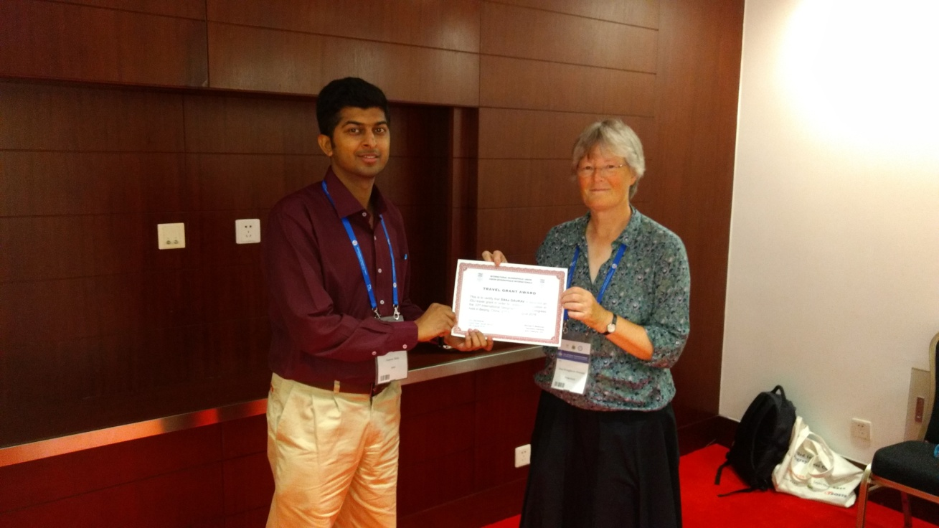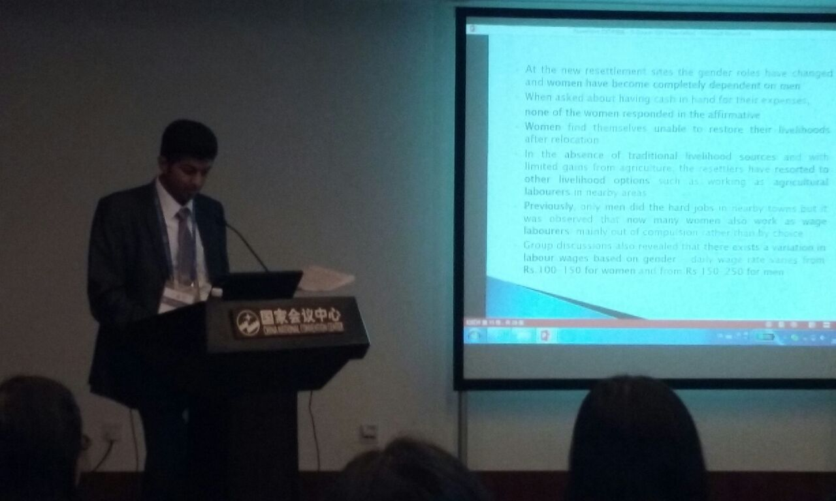
Receiving IGU travel grant award from Prof. Joos Drooglever - Presenting paper in the session of Gender Commission- Gendered Aspects of Migration and Multiculturalism

Darshan Kumar Jha, Ph.D. Research Fellow
Dept. of Geography, Institute of Science,
Banaras Hindu University, Varanasi-221005, INDIA
Mob: +91-9455210319, Email: darshanjha@gmail.com
Dear IGU Travel Grant Committee,
I have attended 33rd International Geographical Congress held at China National Convention center in Beijing, P.R. china from 21st August to 25th August, 2016. This is really mind-blowing and brainstorming conference for me where I met and listen various learned geographers and fellow young researcher come from all over the world.
On 21st August , I reached Beijing and reported at registration desk and received conference kit and enjoyed reception party. On 22nd August I have attended opening ceremony and after that listen plenary lectures given by three notable speakers Mark Stafford Smith, Bojie Fu and Woo-ik Yu. After that I met Prof Joos Droogleever Fortuijn,VP, IGU and received travel grant award. This was very important moment of my life. After that I took active participation in launching session of IGU taskforce on Young and Early Carrier geographer and attended master class on grant and funding. We discussed about various problems of young scholars in their academic life, in this session Prof. Joos and some other senior geographer gave some ideas to solve these problems. We fellow young geographers decided to create a database of young geographers and mentors which will help us. On 23rd August I listen some speakers in urban geography commission session and after lunch I visited exhibition area and met fellow geographers come from different parts of world. I also visited poster presentation area and discussed with presenters about their research.
On 24th august I presented my paper”Spatiotemporal Analysis of the Relationship Between Urbanization and Urban Poverty in India: A New Perspective” in the session C12.39 in room no-406 chaired by Prof Chaulin Gu and Prof Denis Pumain. After presentation, I replied some of questions of listeners and Prof Denis appreciated my presentation and it is really very pleasant moment for me. On 25th August, I attended closing ceremony where my name has been announced as travel grant recipient . I also listen remakes of IGU awardees and got information about upcoming IGU conference and new elected IGU executive committee.
I visited Great Wall of China at badling and explore Beijing city on 26th august. The Beijing is a modern city and help me to understand Chinese urban development model. The discussion with Prof. Celina Rozenbeltz, Prof. Denis Pumain,Prof. B. Maharaj and Prof. Michel midos broadened my horizon about geography in general and about urban studies in particular. I also met many young fellow researchers come from different parts of world and discussed about various geographic topics and I made some friends from Romania, Russia, India, China, USA, brazil and South Africa.
At Last I would like to thank IGU travel grant committee to award me this travel grant because without grant I was unable to attend the conference. This conference has really boosted my academic and research knowledge as well as broadens my academic circle.
With Regards

Edmore Kon
Presentation title: A Characterisation of Resilient Agro-Small and Medium Enterprises in Zimbabwe
Co-Authors: D. Shoko and E. Kon
Summary of Conference: The congress was convened at the Beijing International Convention Centre. The theme of the conference was Shaping Our Harmonious Worlds. This theme is in line with the day to day challenges facing the world. These challenges call for the sustainable living of humanity in the natural environment. They call for unity in solving them for the creation of a sustainable human-environment relationship.
Knowledge and skills gained by attending conference: This conference provided me with benefits from three perspectives – academic growth, networking as well as collaboration opportunities.

Presenting my paper and listening to other presentations gave me academic growth. Feedback from the audience who listened to my presentation made me realise some mistakes which have made me a better academic. Listening to other people present their work was a huge learning curve for me. I especially enjoyed presentations from gurus in the field of geography, especially Physical geography. This gave me whole new perspectives about the field of geography in general and physical geography in particular.
The presence of different geographers as well as publishers from different parts of the world presented a huge opportunity for networking. I got to meet other geographers with the same interests as mine who I could collaborate with. In addition, there were a number of reputable publishers who had new insightful publications.
Benefits from the knowledge and skills: As a PhD candidate all the skills and knowledge will go a long way into assisting me to come up with academically sound theses. I listened to presentations in GIS, geomorphology and climate science. These three components are the pillars of my PhD and I am sure I gained useful skills that will enhance my research.
As an academic, I will use the knowledge and skills I acquired in the discharge of my duties. I will make sure that my students use the current information I gained from the congress as they build their careers.
Recommendations: Attending an IGU congress is one thing I would recommend every geographer to do. This is the place one meets the who’s who of geography. This is where the most current geographical knowledge is brewed and shared. I strongly recommend that whenever a chance presents itself, especially with the support from the IGU Travel Grant, all geographers – emerging or established – should attend all IGU conferences and congresses.
On the side of the IGU leadership, I wish they could cause some good papers form the congresses and conferences to be published. IGU is the global body representing geographers so publishing papers from its conferences and congresses is surely guaranteed to reach the highest possible audience. Best papers may be published in a high impact IGU journal. Each commission may also publish its papers. This will go a long way in assisting emerging geographers.

Patricia Matsumoto. São Paulo State University, Brazil.
Being a participant in the 33rd International Geographical Congress was a great life experience. During the conference, I realized what has been produced and discussed in my research area. I study a neglected disease, Visceral Leishmaniasis, and it played a vital role in my studies attending the sessions about Health and Environment - Environmental Change and Health and Health and Environment - Health and GIS. In such sessions, I presented two papers. The first one as the first author discussing the spatiotemporal analysis of this disease in Brazil, and the second one as co-author, contributing to the assessment of environmental-disease changes.

Attending the conference makes it possible to learn about other geographies of health and to exchange experiences. In these sessions, I knew notable names in Geography of Health. I could make contacts, creating a network about our research and made some friends. I also learned about other sides of Geography attending other sessions, where I had a great experience when knowing about other researchers' contributions to the Global Geography.
One of the most important activities to me was the Masterclass: “Finding Funding and Grant Proposal Writing” Younger Early Carrier task force. In the first part of the afternoon, we could share experiences, projects, doubts and so on. In the second part, the professors presented their subjects. It was taught to seek continuous improvement and how to do it. I highlighted important questions presented: 1) how to survive being a geographer and a teacher. More than that: 2) how to survive being a geographer, teacher, and woman. The professors gave us many precious tips to answer these questions and survive our career. The focuses were: To make plans, form networks, alive, have personal experiences, and produce. Also, finding funding and grant propolsal writings. I think that the Masterclass was so important because we are already successful students to have attended this great international conference, to taking the award and to spend our energy being a young early career. However, we are beginning the journey, and we need to keep focus to be a successful researcher now and in the future.
The plenary lectures were outstanding Geography knowledge space. Professors presented themes focused on geographical sciences and future earth, China (science and society), a territorial way of life, urban dynamics, geographies of health and care, climate changes, Geography and perspectives from Africa, global sustainability, and political geographies. What caught my attention was the presentation of Professor Mark Rosenberg, about the social justice and health. Professor Mark let us think how we can move to justice in the world with geographical changes in 2 different worlds: one of poverty and other surviving the changes.
I also would like to highlight the plenary lecture about the life experience of Professor Woo-ik Yi. Two phrases said by him translate my feelings about Geography. “To be a geographer means, first of all, think geographically” and “once geographer, always geographer”. The lecture gave us some tips about how to think geographically, understanding different disciplines (spatial and synthetic), coordinating opinion and policies (holistic and convergent), making vision and strategy (practical and policy oriented). And to this, we need to make our globe more diverse and harmonious and to put more efforts into reasoning the territorial way of life. I think that this lecture also translates the name and the idea of the 33rd International Geographical Congress: Shaping our harmonious worlds. That is, just thinking geographically we can shape our harmonious worlds.
The dinner was an important moment to know people and make contacts and friends. Also, to discuss our researches in an informal way. We spent a great time with good food and good company.
In general, to have attended the 33rd International Geographical Congress held in Beijing was an incredible experience. The conference gathers all geographical thematics, allowing us to attend for curiosity other geography subjects. As common, in Geography, as we have many research areas, we attend, particularly, small conferences focused on our research subareas. This is not enough to create a geographical thought. We need to discuss more Geography, and the 33rd International Geographical Congress was the perfect place to do it.
Being able to visit and also having this life experience in China was the greatest achievement of my life. For Brazilians, China is a spatially distant country, but, being able to have an insight of the culture and its people makes me want to go back there as soon as possible.
I would like to thank the committee for bringing the possibility of my attendance to the conference, and for all the support and time spent to make this event achieve such great milestone.
Presidente Prudente - SP - Brazil, 19th September 2016.
Patricia Matsumoto (Doctoral student from São Paulo State University - Brazil)

Sinenhlanhla Memela

Rhodes University,
Department of Geography
Mail: s.memela@ru.ac.za
I would like to thank IGU for awarding me with travelling grant to supplement grant having received from Rhodes University. Being part of the IGC was a great opportunity for me as it gave me a chance to engage and interact with other researchers from all over the world. As a new emerging scholar I was able to learn from others, meet potential collaborators and create networks.
I attended opening, dinner and closing ceremony of the conference as well as the following sessions:
22 August- I attended Young and Early Career Task Force and a masterclass where I joined the committee and learnt to write grant proposal, budget, key strategies for getting research published and working in a collaborative project.

23 August- I attended Global Change and Human Mobility sessions as well as joint session Urban Geography/Global Change and Human Mobility where I presented my paper. Attending Global Change and Human Mobility sessions also gave me a chance to meet people that I published with, a chapter of the homonym book ‘Global Change and Human Mobility’, which was edited by the chairperson of the Commission under

the Springer series Advances in Geographical and Environmental Sciences. 25 August I attended Political Geography session.
On the 24th of August I participated on the local tour: Forbidden city, Temple of heaven and Tienamas Square where I learned about Chinese culture and history.
Attending the 33rd International Geographical Congress, Beijing, China was a great leaning and entertaining experience.

Ogunleye
The 33rd International Geographical Congress held in Beijing China from 21st - 25th August 2016 served as a great opportunity to learn about the role of geography and geographers in
“Shaping Our Harmonious Worlds” at various scales. It furthermore proved to be a veritable platform for networking and knowledge exchange, as I met young geographers and established geographers from across the world.
The reception party held on 20th August was an exemplar of what to expect in Beijing. While there was much to eat and drink, the informal setting provided room to mingle. I met many people with whom I had continuous engagement with throughout the duration of the congress.
While I would have loved to have attended more plenary, oral, and poster sessions, the vast amount of options and the fact that some of the tours occurred simultaneously with sessions limited the number of sessions I could attend. The opening ceremony and first plenary session were commendable, especially the keynote address of Professor Woo-ik Yu, which revealed the strategic role geography and geographers can play in nation building and international diplomacy.
I attended the Young and Early Career Geographer’s Survival Guide session and the Gender and Geography- Addressing Gendered Insecurities in the Urban Global South On 22nd August 2016. The launch of the IGU Young and Early Career Geographers Taskforce is a good initiative which will provide a platform to strengthen the relationship established with other early career geographers. The session provided an opportunity to learn from the experiences of others as it covered various aspects of the career of an early career geography such as accessing jobs, position oneself as a geographer, and the psychological issues early career academics face. I took the opportunity to join the Taskforce. The session on Addressing Gendered Insecurities in the Urban Global South shed light on experiences from other countries in the global south, which I found insightful, especially since the issue of (in)security in south-south cities is a research interest of mine.

Husnul Fitri Sundoko
From 21st-25th August 2016, the 33rd International Geographical Congress was held in Beijing, China as one of the most important event for geographers. It was huge, enarmous and also memorable not only derived from the well preparation from the host but also because it stood in the peak of uncertainty of our global world problems: conflict, insecurity, climate change. The organizer also stated that more than 5000 presenters joined the event to nail the interest and passion toward this congress.
Elaborating the themes of “Shaping Our Harmonious World”, it is clear to me that the wold our live in is far from being a state of harmony. The complex problems faced from many regions presented by scholars in this events highlighted the unique characteristics resulted from different culture, social-political and environmental condition. Our understanding is challenged to deal with the same problem from another perspective while considering local and indigenous distinctiveness to the social and ecological rapid change. But it encourages the responsibility from the geographers and related profession to develop the methodology to provide the best solution in the future. The mission is not to shape the world to be harmonious in certain ideal concept but to accept and undergo the distinctiveness because the harmony will only be achieved by admitting differences as a part of our perfect harmony.
The event promoted many attractive themes such as gender, transportation, information society and security with the latest interesting topics and research. There were also several plenary lectures from distinguished speakers such as Prof. Mark Stafford Smith, Prof. Bojie Fu, Prof. Woo-ik Yu, Prof. Mark W. Rosenberg, Prof. Dahe Qin, Prof. Michael Meadows, Prof. Benno Werlen, Prof. Virginie Mamadouh and Prof. Takashi Yamazaki addressing interesting topics from different kind of perspectives. Meanwhile, in the paper and poster sessions I noticed that young scholars from China in particular contributed in many session represented the positive development of geography as an important discipline for future regeneration of scientist in this field and region. But I also concern that some countries in Southeast Asia which I believe have an influential research in many topics such as Malaysia, Indonesia, and Philippines were not represented well. It could be by the reason of technical consideration such as limited funding problem and the distribution of information or probably the inactive involvement. I appreciated the effort of IGU and local organizing committee to provide several kinds of grant to reach participants from many different countries but I hope IGU as the main institution will try to incite more involvement from Southeast Asia and I expect to see the role of scholars and academicians from those countries in the near future to complete our global understanding to face the more complex problem.
Although this event finished more than a month ago but the celebration of gaining new knowledge and understanding are still remaining to make sharp contribution toward better world in the hand of geographical perspectives. As John Locked said, “The only fence against the world is a thorough knowledge of it”. Hope to see more in the next anticipated 2020 Geographical Congress in Istanbul, Turkey!

Alena Zelenskaia, Russia/Kyrgyzstan
Summary: The report highlights the activities that emerged during my participation in the 33rd International Geographical Congress in Beijing, China. Ahead of delivering two talks on refugees from post-Soviet countries in Germany, I visited other sessions as well as plenary lectures. As an early-career researcher I made new acquaintances with colleges from different parts of the world and discovered China.
Introduction
A scholar should be seen nationally and internationally. That is a dogma for the whole academic world. While the participation at domestic conferences and seminars is more or less always possible, it is not easy for a young scholar to give talks on international conferences. For me it was the first experience of participating in an international and - at the same time – in such a huge (over 3000 participants!) academic event. After defending my Master thesis on a theme, that was a great pleasure to work with, it meant a lot for me to obtain an IGU Travel Grant and to receive the wonderful opportunity to present the results of my work at such a level. Moreover, it gave me a chance to meet my colleagues and to share thoughts. The 33rd International Geographical Congress has fully justified my hopes.
IGC 2016: Activities
Every day at the Congress was preplanned for me. As many others I spent the first day – the 21st of August - on Registration procedures and at the Reception Party. The IGC volunteers assisted a lot. When I found out that I needed correction of a factual mistake in my presentation, volunteers were very cooperative. With the use of their software I could fix my problem.
All four congress days were marked by visiting plenary lectures and oral sessions. Although every topic was worth attention, I tried to be present on those, which were relevant to my research interests. These were the following sessions: “Population Geography” (C12.34), “Gender and Geography” (C12.10), “Global Change and Human Mobility” (C12.17).
On the 22nd of August I took part at the masterclass “Finding Funding and Grant Proposal Writing”. During two helpful academic hours we learned how to develop our careers and to write grant proposals. A group work that was integrated into the masterclass encouraged us to ask questions and discuss the problems that young researches sometimes encounter. Prof. Saarinen discussed the following questions with us: How many publications should a young scholar have? Is it better to divide Master thesis or PhD thesis in several articles or to make just one, but of a very decent quality? Is it possible to do an independent research without being enrolled in a study program? etc.. For me it was an honour to summarize the results of our group work.
I myself was to give two oral presentations at C12.34: “Demographic Divide: Coping with Growth” and “Processes of Population Change and Migration”. My first talk was devoted to the motives of migration of asylum-seekers from several countries of the ex-Soviet Union to Germany. The other doubled the topic of my Master thesis and sounded like “Identities of Refugees from Post-Soviet Countries to Germany”. Both of the talks were scheduled at the same day: on the 23rd of August. Unfortunately my acquaintance with the Chinese cuisine turned evil on me, and the day before the presentations I got a very strong food poisoning. I managed to move one of my presentations to the next day. For this I need to thank professors Jianfa Shen and Yu Zhu and the fact that the oral sessions of “Processes of Population Change and Migration” lasted three days, therefore there was an opportunity to give a talk on one of the other days. The first presentation I held on the 23rd, notwithstanding my state of health. And I am sure that it was the right decision, because at Prof. Gans´s session I met a professor from the Chemnitz University, who had come specially to hear my talk and with whom I exchanged contacts.
The presentation held at the session of professors Shen and Zhu was also favourable to me. This session was one of the biggest, therefore there were always a lot of attendees. After my talk one professor from Romania offered me to publish my presentation in form of an article in a Romanian academic journal.
In general during my time at the Congress I met a lot of colleagues and established new contacts. To Kyrgyzstan I brought back 15 business cards.
Conclusion
The 33rd International Geographical Congress was my first international academic event. Without the travel grant it would not have happened. My biggest achievements are my oral presentations and a certain attention among the interested listeners. Although I had planned to volunteer at the stand of the Russian Geographical Society (RGO), that was unfortunately not possible. Before I went to China, I contacted the youth organization of the RGO, but did not receive any answer. By chance I got to know the organizers of the RGO-stand on my second day in Beijing. They explained that the person I contacted firstly had been on vacation and then got ill. They stated that they were in dire need of volunteers. As mentioned before I got ill and thus could not spontaneously help them out.
Due to a tight schedule and my everyday presence on the Congress I could not find the time for visiting the Great Wall of China. On my last day in China, after the Closing Ceremony, I managed to visit the Forbidden City and a couple of temples. Although I feel a little bit upset that my cultural trip was shorter than I initially planned, the scientific objective of my journey to China was met.

5) REPORTS OF RECENT EVENTS

5.1) IGU Conference on ‘Urbanization, Health & Well Being and Sustainable Development Goals’
This conference is the 10th in the series of Theme based organized by International Geographical Union (IGU) in the recent past. It was hosted by the Department of Geography& Geoinformatics, Osmania University, Hyderabad from17-19 March, 2017 at the Marri Channa Reddy Human Resource Development Institute (MCR-HRD ) Institute at Jubilee Hills in Hyderabad, Telangana, India.
A total number of 306 papers were presented in 25 technical sessions and in plenary session.. For the first time a Poster Session was organized in the conference and it carried three best young scientist (poster) awards. Over 400 participants took part in the deliberations of the conference. Of this number 345 represented 25 states of India and about 60 were from Hyderabad. Indian participants were from universities, institutes, govt. departments, industry etc. Around 28 International participants from 15 countries (Japan, China, Russia, Switzerland, South Africa, Poland, Italy, UK and Sri Lanka) also attended.
The conference has discussed a variety of viewpoints to the topics, milieus and methods of study covered in the conference. The main themes focused on Biodiversity and Climate Change, Natural Hazards and Disaster Management, Urban Planning and Infrastructure, Urban Morphology and Hierarchical System, Urban Transportation and Waste Management, Natural Resources and Environment, Sustainable Development Goals, Urban Health and Well-being. Youth, Gender and Society beside Urban Safety and Governance,
Besides the President of the IGU, three Presidents of different IGU Commissions were present for all the three days of the conference. Simultaneously with the Conference, an International Training Workshop on Big Data for Science and Sustainability in Developing Countries was also held. It was organized by representatives from the Chinese Academy of Sciences. Around 57 participants took part in this three-day workshop. Students of Osmania University presented a ‘cultural fiesta’ on day one. The conference concluded with valedictory function on the last day, in which the (Late) Dr Manju Singh Memorial Young Scientist (Poster) Awards were distributed to the winners.

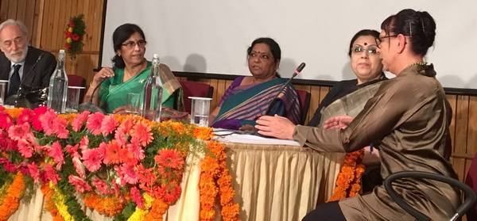
Kalpana Markandey (green dress) chairing the Inauguration Plenary Session
(Photo sent by Dr. B. Srinagesh)

5.1a) IGU-YECG Late Dr. Manju Singh Memorial Young Scientist Poster Award:
A Report
The IGU Young and Early Career Geographers Taskforce (IGU-YECG) and the Organizing Committee of Xth IGU International Thematic Conference had organised a poster competition for IGU-YECG LATE DR. MANJU SINGH MEMORIAL YOUNG SCIENTIST (POSTER) AWARD on 17th March 2017 at Hyderabad, Telangana, India. Mr. Gaurav Sikka (India) from the steering committee of IGU-YECG coordinated the event.
The IGU’s Young and Early Career Geographers Taskforce (IGU-YECG) was launched in 2016 at the 33rd International Geographical Congress in Beijing, China. The Taskforce Steering Committee comprises ten members globally and its primary aim is to stimulate young geographers to participate in IGU activities.
During the Xth IGU International Conference on “Urbanization, Health & Well Being and Sustainable Development Goals” from March 17th -19th, 2017 at Osmania University, Hyderabad, IGU-YECG aimed to present a special poster award, to foster the excitement of younger colleagues in presenting their work in the form of a poster. Therefore, posters were invited from young scholars on the theme and sub themes of this conference. The award is instituted in the memory of Late Dr. Manju Singh, daughter of Prof. RB Singh (Vice President, International Geographical Union). Dr. Manju Singh, a young and dynamic academic did her M.Sc. from USA and PhD in nanotechnology from Italy. She left for her heavenly abode after a prolong illness on 9th December 2014. Prof. RB Singh has been generous enough to provide financial support for this award.
Eleven poster presentations from India and abroad were made in this competition. The jury for the award competition comprised of: Prof. Yukio Himiyama (President, IGU), Prof. Celine Rozenblat (Chair, IGU Urban Commission) and Prof. Aravind Mulimani (Karnatak University, Dharwad). Awardees were selected on the site by jury and award recipients were announced during the valedictory session of the conference. The award included a certificate of merit and monetary award of Rs 5100/-. Two consolation certificates were also given.
The award is bagged by S. Abdul Rahaman from Department of Geography, Bharathidasan University, Tiruchirappalli, Tamil Nadu for his poster on “Assessment Of Human-Induced Land Degradation and Its Impact Through Geospatial Based MCE Approach In Kallar Watershed Of Tamil Nadu”. The consolation certificates 2nd & 3rd position was won by Gaurav Kant Nigam from Indira Gandhi Krishi Vishwavidyalaya, Raipur, Chhattisgarh and Tejpal Sharma from Kurukshetra University, Haryana respectively.
The event was hailed by entire geographers’ community and appreciated by the young scholars. The task force aims to make this competition a regular affair with organizing the poster award in XI IGU Commission Seminar 2018 scheduled in Assam, India.
Gaurav Sikka
Member-Steering Committee, IGU’s Young and Early Career Geographers Taskforce

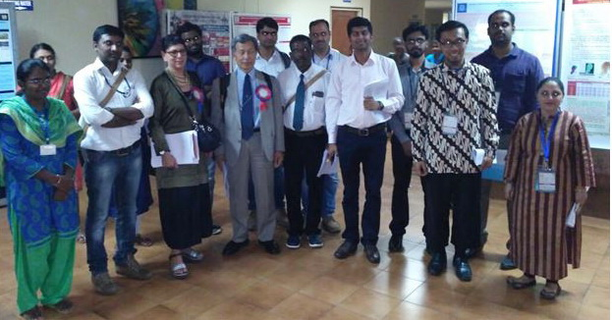
IGU President Yukio Himiyama and Céline Rozenblatt, Chair of the IGU Commission on Urban Challenges in a Complex World, with the Poster Awardees of the IGU-YECG Dr. Manju Singh Memorial (Photo sent by Dr. G.Sikka)

5.1b) Visit to the Osmania Human Resources Development Center

During the Hyderabad Conference Giuliano Bellezza, Newsletter Editor and former IGU VP, and his wife Ester have been very interested by the activity occurring in the Osmania Human Resource Development Center. This happened because in the late ‘90s they had been assigned by the Italian Ministry of Education to prepare selected Geography School Teacher Trainers to carry out, in the following years, the task of preparing the School Teachers of Geography. Furthermore, in 2000 and 2001 they have been charged to prepare DVD on Geography as holistic discipline.
Given all this, it has been very interesting discover that the above-mentioned Center in Osmania organizes courses of two weeks for teachers of all disciplines coming from all India, to give a similar teaching standard all over the Country. The Director, Prof . Bala Kishan, is a Geographer, and in those days the Center was hosting some teams of teacher, just of Geography. It has been a very lucky opportunity to enter in contact with them exchanging opinions on the way India and Italy are taking care to organize a similar national standard of teaching. In conclusion, me and my wife are convinced that the Indian way is better, because all the teachers receive a similar training.
In Italy the teachers followed a course of 3-4 days and a DVD, and were supposed to give similar training courses in their respective Regions to the local teachers. Beyond any doubt, these courses couldn’t be all at the same quality level, but the bad thing is that, in the last years of expanding globalization, in Italy the hours of Geography teaching in the High Schools are dwindling (a globalized phenomenon, unfortunately).
We wish best success to this Center in Osmania, and we are very worried: can you imagine taking care of the Teachers (not only of Geography) in a Country with 13.5% of the world population? Even though they have English as common language, it is incredibly challenging.

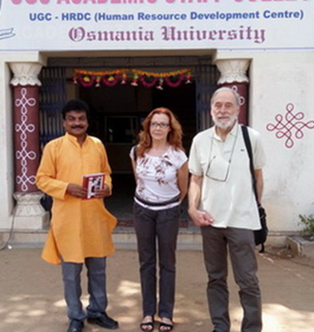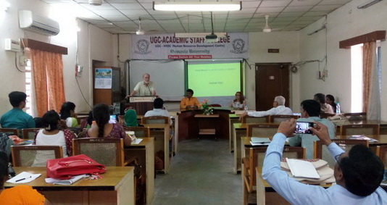
Left: Prof. Bala Kishan, Ester and Giuliano Bellezza. Right, one of our encounters
with Geography teachers coming from several States of India.

6) Presentation of a new IGU Commission

News from the IGU’s newest Commission: Agricultural Geography and Land Engineering I am currently visiting Professor in the School of Geographic Sciences at East China Normal University, Shanghai, China. During my most recent period of residence there, I had the privilege and pleasure of being invited to join members of the IGU Commission on Agricultural and Land Engineering excursion to Fuping County, Hebei Province, a rural and largely mountainous district around 50 km around 50km SW of Beijing.
The mission of this commission targets the improvement of agricultural conditions in different environments by way of land engineering which helps to increase and productivity and agricultural production. It focuses on the role of land engineering in consolidating land resources and improving the agricultural conditions of different areas and, indeed, this was the theme of the field excursion.

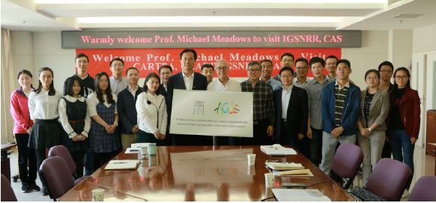
Celebrating the launch of the IGU Commission on Agricultural Geography and Land Engineering. Professor Yansui Liu and Secretary –General Meadows with colleagues from the Institute.
The trip was organized by Yansui Liu and Yuheng Li, chair and secretary of the Commission respectively. Both are affiliated to the Institute of Geographical Sciences and Natural Resources Research of the Chinese Academy of Sciences in Beijing (although Professor Liu was unable to join the excursion due to prior commitments. Fuping County, along with other rural regions of the country, has been a target for China’s poverty alleviation and it was fascinating to witness the various elements of the programme – there are concerted efforts here to improve the quality of life for its rural inhabitants through a diverse range of interventions, including investment in agricultural infrastructure, development of agricultural-related and other industries, e-commerce initiatives, education and health facilities and relocation from remote mountain villages. We visited Dahubo and Luotouwan villages, where the population consists almost entirely of the elderly due to the migration of younger people to the regional urban centres.

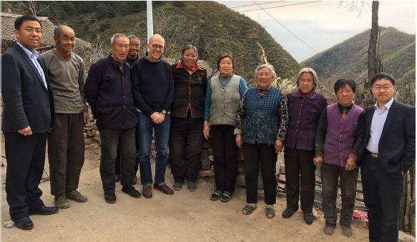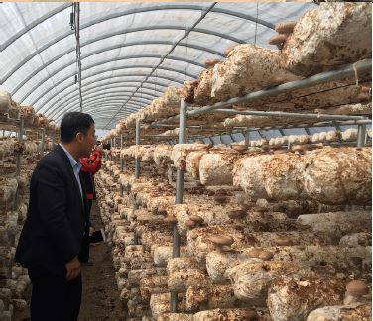
Left: The group meets with members of the local community in the small mountain village of Dahubo. Right: Scenes from the impressive Tianshengqiao mushroom production facility.
This was followed by a tour of one of the numerous mushroom farms, at Tianshengqiao, where edible fungi are produced on an industrial scale in an innovative way that facilitates the involvement and investment by the local population. A highlight of the trip was the site visit to the Songjiagou research base, one of several in China operated by Professor Liu’s group. The base is set in limestone and gneiss mountainous terrain where land suitable for crops is very limited. Here there is a landscape-scale geo-engineering project that has seen 13000 hectares of the terrain terraced for irrigation agriculture, especially for apples and including other fruit trees and market garden produce. The geomorphological transformation is truly remarkable. A major feature of the group’s work is that the research work is conducted in close collaboration with community leaders and government authorities. To bring this kind of land into more efficient agricultural production requires a huge amount of effort, funding and technological innovation and the research group is documenting and monitoring diverse aspects of this extraordinary programme.

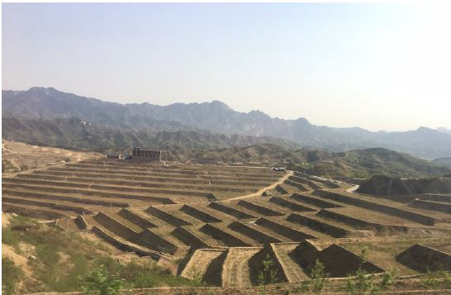
Landscape-scale geomorphic transformation at the Songjiagou research base

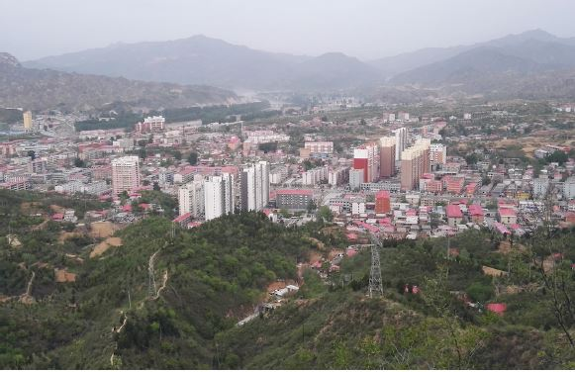
The town of Fuping showing typical hilly terrain of the county

The new commission is organizing its inaugural conference in August 2017 in Yulin and it is clear from the work that was showcased on this field excursion that the delegates are in for a fascinating conference in the very capable hands of Professor Yansui Li, Yuheng Li, Yang Zhou, Haualou Long and colleagues. I wish to thank them, including those members of the Fuping community, for making me feel so warmly welcome. I have learned once again that there is no hospitality like Chinese hospitality!

Mike Meadows,
Secretary-General and Treasurer International Geographical Union

- FROM ICSU NEWSLETTER, MARCH 2017

NEWS

The Council called on the government of the United States to rescind the Executive Order “Protecting the Nation from Foreign Terrorist Entry into the United States.” In the opinion of the Council, the Order is inappropriately broad in its scope and unfairly targets individuals based on their origin, putting it into violation of the Principle of Universality of Science, enshrined in the Council’s statutes.

Call for pre-proposals: Advancing the implementation of Sustainable Development Goal 11 on cities in Africa. As part of the 5-year "Leading Integrated Research for Agenda 2030 in Africa" programme, the Council will support 10 collaborative research projects across Africa (to the value of up to 90,000 Euro each over two years) that will advance the implementation of the Sustainable Development Goal (SDG) 11 (sustainable cities and communities) in Africa.

On the International Day for Women and Girls in Science, the Council held a workshop on applying a gender lens to international scientific research production and coordination. In partnership with GenderInSITE and the International Social Science Council, the event discussed ways to develop a gender-lens for large international scientific research production and coordination initiatives within the context of new modalities for producing and coordinating scientific research

The scientific and technological community delivered statement at the United Nations on Oceans. The statement announced the upcoming launch of the Future Earth Knowledge Action Network on Oceans and called for strong partnerships between science and all sectors of society. ICSU and Future Earth will participate in the UN's conference on Oceans in New York in June, for which a deadline for applications for side events is approaching

Call for original papers on the UN Sustainable Development Goals for a Special Issue in the ISPRS International Journal for Photogrammetry and Remote Sensing. The papers should be covering topics on contributions of photogrammetry, remote sensing and spatial information sciences towards achieving the 17 UN Sustainable Development Goals.

Events
Fourth International Conference on Earth System Modelling (4ICESM). Hamburg, Germany. 28 August - 1 September 2017.
3rd COSPAR Symposium. Jeju, South Korea, 18-22 September 2017.
International CODATA 2017 Conference “Global Challenges and Data-Driven Science.” Saint Petersburg, Russia. 8-11 October 2017.
32nd ICSU General Assembly and associated meetings. Taipei, 19-27 October 2017.
World Science Forum. Dead Sea, Jordan. 7-11 November 2017.

- From Future Earth News, April 2017

Is there intelligent life on Earth?
Watch the video produced by Future Earth for Earth Day 2017
Link: http://www.futureearth.org/blog/2017-apr-21/video-state-planet-2017

The latest from Anthropocene – Innovation in the Human Age
New in Daily Science coverage from Anthropocene magazine: International energy trade and grid connections may be key to electrifying Africa through wind and solar; switching from nuclear to coal power led to smaller babies in the Tennessee Valley; and a new reactor that can turn ocean plastic into diesel fuel. Plus much more. Sign up to receive updates now...
A "Carbon Law" for cutting emissions
Inspired by Moore's Law in the computer industry, a new study in Science lays out a path for making the world carbon neutral by 2050. Researchers say that nations can limit the rise in global temperatures by following what they call a "Carbon Law" – cutting carbon dioxide emissions by half every 10 years. Read more...

Events & opportunities
To see more upcoming events, and share your own, visit the Open Network

Call for applications: SOLAS International Scientific Steering Committee

Deadline 1 June
Nominate experts to play leadership roles in the Surface Ocean-Lower Atmosphere Study (SOLAS).

Social-ecological resilience of freshwater ecosystems in the Anthropecene
8-10 July 2017, Nanjing, China
Register for this workshop focusing on the resilience and management of freshwater ecosystems.

9) FORTHCOMING EVENTS

(more information in the Home of Geography website, Events 2017)
9.1) Balsillie, Ontario, 23-27 May
9.2) HEA’d17 3rd Conference on Higher Edu, Valencia (Spain), 21-23 June.
9.3) ACLA Conference, Urban Cultural Landscape and Urban Regeneration, Vladivostok, 22-24 July.
9.4) IGU Commission History of Geography, International Symposia, Rio de Janeiro, 23-29 July 2017
9.5) International Conference on Natural Computation, Fuzzy Systems and Knowledge Discovery, Guylin (China), 28-31 July

