

Charles University of Prague

Faculty of Science

Department of Social Geography and Regional Development
www.geography.cz/socgeo/

SELMA – Spatial Deconcentration of Economic Land Use and Quality of Life in European Metropolitan Areas

Third Project Management Committee Meeting in Prague

Date: Friday, 23 January to Sunday, 25 January 2004

Venue: The meeting will be held in the building of Faculty of Science at Albertov 6 in Prague 2. The building is easily accessible by walk from the hotel along the street Ke Karlovu and then down by Albertov stairs. Meeting rooms Prava rysovna and Leva rysovna are located on 3rd floor (there will be arrows from the entrance showing the way). Rooms are equipped with PC, data projector, overhead projector (please bring your presentation on CD-ROM).

Accommodation: Hotel Ibis is located on Katerinska Street. 25 rooms are reserved until 20th December. Meeting participants have to book rooms by themselves until this date, otherwise accommodation in the hotel is not guaranteed. The hotel offers standard accommodation, is located close to the meeting venue and rates are relatively cheap on city standards. Of course, participants can choose hotel according their own individual preferences.

Please, book your rooms as soon as possible and than send e-mail to Martin Ourednicek (slamak@natur.cuni.cz) with specification of your accommodation (duration, single-double room). After 20th December I will check your reservations in situ. The best possibility is to make reservation immediately via Internet (http://city.hotelibis.cz/) or using e-mail (H3195-re@accor-hotels.com) or fax (+420 222 865 666).

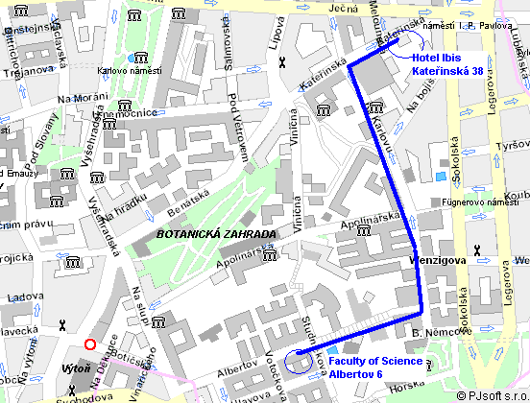
Programme:

Friday, 23 January 2004

09:30 – 10:30 Welcome and short presentation of the host organisation
Agenda of the meeting
Approval of minutes from Madrid

10:30 – 11:00 Coffee break

11:00 – 12:30 WP2 – Quality of Life
Conceptualising quality of Life (CUNI, RIVM)
Quality of Life Indicators (HUJI, RIVM)
Weighting and Scoring System (HUJI, RIVM)

12:30 - 14:30 Lunch

14:30 – 16:00 WP3 – Taxonomy – Economic Land Use Deconcentration (UGA)

16:00 – 16:30 Coffee break

16:30 – 18:00 WP4 – Data Base Assembly (RIVM)

19:00 – 21:00 Dinner offered by CUNI – Restaurant Hlucna samota (“Noisy Loneliness“) dedicated to writer Bohumil Hrabal and located in Vinohrady neighbourhood in the middle of gentrifying area (address Zahrebska 14, Praha 2, www.hlucnasamota.cz).

Saturday, 24 January 2004

09:30 – 12:30 Field observation – bus tour through Prague´s suburban areas guided by Ludek Sykora

12:30 – 14:30 Lunch in suburban town Pruhonice

15:00 – 17:00 WP5, 6, 7

Free evening – list of cultural events will be offered in advance

Sunday, 25 January 2004

09:30 – 11:00 Project management issues

Further and up-to-date information is available from SELMA CUNI www pages:
www.geography.cz/SELMA

Contact to Ludek Sykora in any emergency case 00420-605-525604

