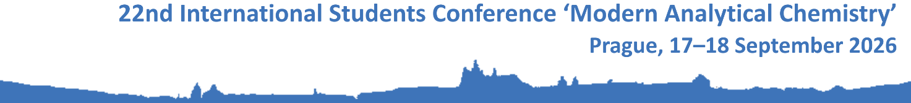

Registration Form

1. Personal details
Title (Mr. / Mrs. / Ms.)
First (given) name(s)
Surname
Organization (in English)
Organization’s address
Postal code, city
Country
E-mail address

2. Title of the contribution

3. In the conference proceedings, I will publish:
abstract / full contribution

4. Interest in the publication of the contribution in the conference issue of the journal Monatshefte für Chemie
The organizers of the 22nd International Students Conference ‘Modern Analytical Chemistry’ are in negotiations with the editors of the journal Monatshefte für Chemie-Chemistry Monthly (IF₂₀₂₃ = 1.7, Q3) on the possibility of publishing selected contributions presented at the conference as regular articles in this journal. Are you interested in this possibility?
YES/NO

5. Accommodation
I require accommodation from 16th to 19th September 2026.

6. Lunches
I require the conference lunches by the organizers:
September 17 | YES/NO
September 18 | YES/NO

Please indicate if you have any limitations (e.g., vegetarian food):

7. Any other notes/requirements

